The Rite Place
Liturgy Template

How to use this template:

Open your copy of The Rite Place and go to Chapter 7: The Liturgies, on page 58. Review this document in its entirety to one or more of the liturgies. You will note this template uses a table format in order to keep the icons, the movements of the liturgy, and the sidebar text properly aligned.

Next, save a copy of this template named “Master Copy” to your computer. This will enable you to return to it as needed.

Finally, save a template named for the liturgy you plan to celebrate (such as Advent) and add your text.

If you want, you can turn off the table borders before you print copies. Select the table (hover over the upper left hand corner of the table and click on the arrow icon that appears), navigate to the “Table” drop down menu located on the menu bar at the top of the document, select Table Properties, then Borders and Shading, and setting “none.”

Within this template you can customize the liturgy according to your own church’s practice and insert information about your church, such as your address, website, phone number, and worship times.

The Rite Place
Season Name

(Insert image)

Welcome
Text explaining The Rite Place is placed here.

Season Name
Text explaining the season is placed here.

Watch for these symbols and meanings:

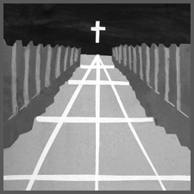  Procession | 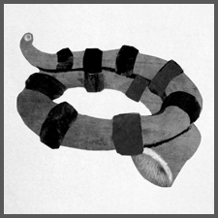  Shofar | 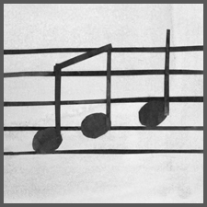  Music | 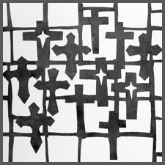  Crosses | 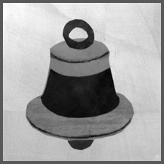  Bell
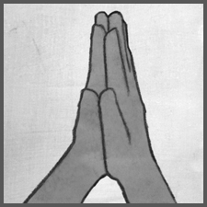  Prayer | 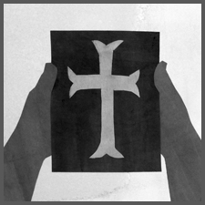  Bible Reading | 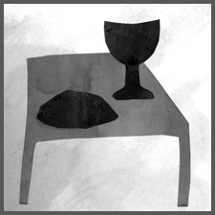  Communion | 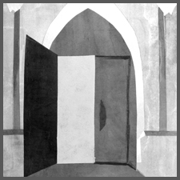  Welcome & Dismissal | 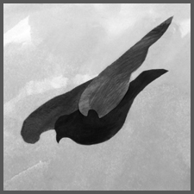  Holy Spirit

We gather with our questions
as spiritual seekers on a journey.

We gather to find God.

 | A Gathering Time | We gather in the name of the God three-in-one or the Triune God, at the entrance to the church. We say hello to God and one another. We take time to see and welcome our neighbor.  We prepare.
 | Welcome
 | Sounding of the Shofar | Israel used the ram’s horn, called a shofar, to call together the people of God.
Member:
Assembly:
 | Opening Song | We sing a gathering song and process down the center aisle.
 | The Procession
 |  | Please feel free to carry an instrument, streamer, cross, or candle as we walk down the aisle. Place these objects in the wicker baskets when we approach and surround the table.
 | We Begin to Pray  The Collect of the Day | This prayer is called the Collect. The Leader or Priest “collects” or “gathers” the themes of the lesson, the church season, and the congregation into one prayer.

The Word of God: God Speaks.
We Listen and Respond.
 | We sing
 | A Story from the Hebrew Bible (Old Testament) or New Testament.  Reader:  Assembly:  or | The Old Testament is also known as the Hebrew Bible, and contains the books that were written before Jesus was born. The New Testament contains the Gospels and Epistles (letters) and the Book of Acts written by a person who knew about Jesus.
 | Deacon or Presider: The Good News about Jesus as told by ______.  Gospel Refrain  Assembly:  (Insert music) | The Deacon (or someone else) tells us the story found in the Gospel appointed for this Sunday of the Church Year. This reading is always from one of four books, Matthew, Mark, Luke or John found in the Bible.
 | We sing the Gospel Refrain again.
 | Homily | We tell about the scripture reading and what it means for us ad how we live our lives.
 | The sound of the bell calls us to a moment of silence.

Baptismal Promises (optional)

Adult in the assembly:
Assembly:

 | We Pray the Prayers of the People
 | Intercessor:  Assembly: | One of the most ancient acts of the Church is referred to as Intercessory Prayer. It is also one of the most holy. Holy means “set apart” or for very special use. Prayer is very, very special.  We ask God to help us and the people we care about. We give thanks for God’s love for us and for those whom we love.  Please feel free to name things aloud or silently, any time during our prayer time.
 | We sing
 | The Peace | We shake hands with those around us and say “Peace” or “The Peace of the Lord be with you.”
The Announcements

The Preparation of the Table and the Presentation of the Offerings

 | We sing
 | The sound of the bell calls us to a moment of silence
 | The Holy Eucharist | The Story of Jesus’ meal with his friends.
 | The Great Thanksgiving  Presider:  Assembly: | Eucharist means “giving thanks” and here we give thanks for all the gifts God has given to us. We give some of our money to help the church do God’s work. When we do this, we are saying that we do try to understand that all we have comes as a gift from God, including our money.
 | We sing
 | Presider:  Assembly: | We join with the priest in blessing this meal. Feel free to join in the movements of the priest.  We say the bold words together.  In this prayer, we especially remember that God became human in Jesus, so that he could share our joys and sorrows with us. Jesus showed us by his life and teaching how God wants human life to be.

 | Presider: Send your Holy Spirit upon us and upon these gifts.  Assembly: Let them be for us the Body and Blood of your Son. | This part of the prayer is called the Epiclesis, which means the summoning (calling) of the Holy Spirit. The Church everywhere includes this in the Eucharistic Prayer. Please join in putting your arms out towards the bread and the wine.
 | We sing | This is known as the “Great Amen.” Amen means “yes” or “so be it!” or “yes, I agree God.
 | The Lord’s Prayer

 | The Breaking of the Bread | This bread is broken for us, we sing and we share communion with one another. We give the bread and say, “The Body of Christ (the Bread of Heaven).” We give the wine and say, “The Blood of Christ (the Cup of Salvation).”
 | We sing
 | A Final Prayer and A Blessing
Member of the Assembly or Presider:
Assembly:
 | Presider:  Assembly: | The Priest offers God’s blessings, God’s divine protection, and God’s thanks for the Assembly gathered.
 | Sending Us Into the World
 | Deacon or Presider:  Assembly: | The Deacon (Helper) dismisses the Assembly.

